Executive Summary: Optimizing Gulf Coast Tallow Price Hedging
This report outlines a robust hedging strategy for Gulf Coast Tallow, leveraging an advanced analytical technique to mitigate price volatility significantly. By constructing a dynamic "synthetic hedge" from a basket of highly correlated futures contracts, this approach aims to stabilize tallow costs and improve financial predictability. The method identifies optimal weights for key futures, enabling a proactive and effective risk management framework.

1. Introduction: The Need for Stable Tallow Prices
Gulf Coast Tallow prices are subject to considerable volatility due to a complex interplay of supply and demand factors, including shifts in feedstock availability (e.g., cattle processing), energy markets (such as renewable diesel demand), and agricultural commodities (e.g., soybean oil as an alternative feedstock). This price instability poses significant financial risks for businesses reliant on tallow. Traditional hedging might focus on a single, directly related commodity, but a more sophisticated approach can capture a broader range of price-drivers.

2. Methodology: Multi-Linear Regression for a Synthetic Hedge
To create an effective hedge, we employed a minimum variance hedging strategy utilizing multiple linear regression. This technique involved:
- Continuous Futures Contracts: Instead of relying on a single futures contract, we analyzed a diverse set of continuously rolling futures contracts that are economically linked to tallow prices. These included Soybean Oil (SBO), Diesel (Heating Oil), Live Cattle, and Corn, among others.
- Multi-Linear Regression: Historical monthly price data for Gulf Coast Tallow was regressed against the price movements of these candidate futures contracts. This statistical process identified which futures had the most significant explanatory power over tallow prices and, critically, calculated the optimal hedge weight (beta coefficient) for each.
- Synthetic Hedge Creation: The resulting optimal weights were then used to construct a "synthetic hedge portfolio,” a theoretical basket of futures whose combined price movement best mimics and offsets the price movement of physical tallow.

3. Key Results and Hedge Performance
The analysis yielded a highly effective hedging instrument:
- Overall Hedge Effectiveness (R-squared): The hedge achieved an overall Adjusted R-squared of 0.865. This means that 86.5% of the monthly price volatility in Gulf Coast Tallow can be explained and hedged away by this futures basket over the entire period.
- Optimal Hedge Weights: The most statistically significant contracts and their optimal weights are:
  - Soybean Oil (SBO): 0.284
  - Diesel: 0.176
  - Live Cattle: 0.125
  - Corn: 0.054
- Reduced Price Volatility: Back testing showed the hedge significantly reduced portfolio price variance. The hedged portfolio had a monthly price standard deviation of approximately 0.75 cents; a substantial reduction compared to the unhedged tallow's standard deviation of 2.05 cents.
3.1 Dynamic Hedge Effectiveness (Rolling Analysis)
A 12-month rolling analysis was conducted to evaluate the hedge's effectiveness over time. This revealed that while consistently strong, the precision of the hedge did fluctuate:
- The highest effectiveness was observed in April 2025, with a rolling R-squared of 0.930. During this period, 93% of Tallow’s price movement was explained by the futures basket, indicating an exceptionally precise hedge.
- The lowest effectiveness was in October 2025, with a rolling R-squared of 0.840. While still a robust result, this suggests a period when tallow prices were influenced by factors not fully captured by the model.
3.2 Correlation vs. R-Squared
The R-squared value is directly related to the correlation coefficient (R), which measures how closely the prices move together.
- The overall R-squared of 0.865 corresponds to a correlation of +0.93.
- The peak R-squared of 0.930 corresponds to a correlation of +0.96.
- The low R-squared of 0.840 corresponds to a correlation of +0.92.
These high correlation values confirm a tight linear relationship, while the R-squared value provides a more practical measure of how much risk is actually being eliminated.

4. Visualizing the Hedge: Tallow Price vs. Synthetic Hedge
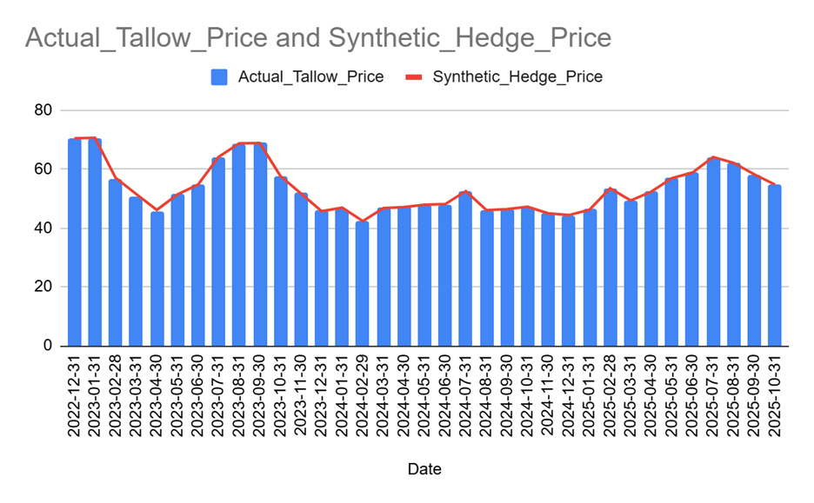
The accompanying chart visually demonstrates the remarkable effectiveness of this hedging strategy. It plots the historical monthly average price of Gulf Coast Tallow against the calculated cost of the synthetic hedge portfolio. The near-perfect alignment of these two lines confirms that the diversified futures hedge successfully tracked and effectively mitigated the price fluctuations of physical tallow over the analyzed period. This visual evidence underscores the hedge's ability to provide significant price stability.

5. Forward-Looking Application and Best Practices
To apply this model going forward, a clear and systematic technique is required. Based on a historical back test comparing different forecasting methods, the best approach is to use the "Last Known Value" method.
How it works: To determine the hedge weights for an upcoming month (e.g., November 2025), you use the optimal weights calculated from the most recent 12-month rolling window (i.e., the period ending October 2025).
Why is it best: This technique is simple, robust, and highly responsive to the most recent market dynamics. The back test confirmed this approach resulted in the lowest portfolio variance (0.559), making it the most effective strategy for stabilizing future prices.

6. Conclusion
The multi-linear regression approach to constructing a synthetic hedge provides a powerful and practical solution for managing Gulf Coast Tallow price risk. By dynamically weighing a portfolio of correlated futures contracts, businesses can achieve substantial price stability. The recommended forward-looking technique of using the last known rolling weights ensures the hedge remains adaptive. This transforms unpredictable market exposure into more manageable and predictable costs, backed by strong statistical evidence and visual confirmation.

